**Data Analytics Assignment-1**

**Name: Subhapreet Patro**

**Roll No.: 2211CS010547**

**Group: 3**

**Q1) Explain the importance of data analytics in decision-making across industries.**

**A)**

**The Importance of Data Analytics in Decision-Making Across Industries**

Data analytics plays a crucial role in improving businesses by uncovering hidden insights, generating reports, and understanding market trends. It helps companies optimize their operations, reduce costs, and make better business decisions. By analyzing large amounts of data, businesses can gain accurate and relevant information to improve strategies, realign goals, and enhance overall performance.

**Importance of Data Analytics**

1. Better Business Performance: Companies can identify more efficient ways of operating and storing data, leading to cost savings and improved efficiency.

2. Informed Decision-Making: Businesses can rely on data-driven insights rather than intuition, leading to more accurate and strategic choices.

3. Understanding Trends and Patterns: Analyzing data helps businesses forecast future outcomes, optimize performance, and understand customer behavior.

4. Competitive Advantage: Data analytics helps companies identify opportunities, streamline operations, and make better decisions, allowing them to stay ahead of competitors.

5. Cost-Effective Solutions: Many industries, including healthcare, finance, real estate, and manufacturing, use data analytics to improve decision-making and reduce operational costs.

**Key Benefits of Data Analytics in Decision-Making**

1. Deeper Customer Understanding: Businesses can analyze customer data to identify buying patterns, preferences, and pain points, leading to better products and services.

2. Improved Decision Accuracy: Data-driven decisions help businesses avoid guesswork, leading to more precise and reliable outcomes.

3. Risk Management and Forecasting: Historical data analysis helps companies identify risks and opportunities, allowing them to take proactive measures.

4. Operational Efficiency: Analyzing operational data reveals areas for improvement, reducing costs and increasing productivity.

5. New Product and Service Development: Understanding customer needs through data analysis helps businesses create products and services that match market demands.

6. Targeted Marketing Campaigns: Companies can segment customers based on demographics and behaviors, ensuring more effective marketing strategies.

**Applications of Data Analytics Across Industries**

1. Retail: Predicts customer demand, optimizes inventory levels, and provides personalized product recommendations.

2. Finance: Detects fraud, assesses credit risk, and optimizes investment portfolios.

3. Healthcare: Analyzes patient outcomes, identifies high-risk populations, and improves treatment plans.

4. Manufacturing: Enhances predictive maintenance, optimizes production, and improves quality control.

5. Marketing: Segments customers, evaluates campaign performance, and generates high-quality leads.

**Q2) Design a data analytics workflow for a company aiming to improve customer satisfaction. Highlight the steps and tools involved**

**A)**

**Designing a Data Analytics Workflow to Improve Customer Satisfaction**

Data analytics follows a structured step-by-step approach to gain meaningful insights and improve customer satisfaction. Below is a simple workflow that companies can use:

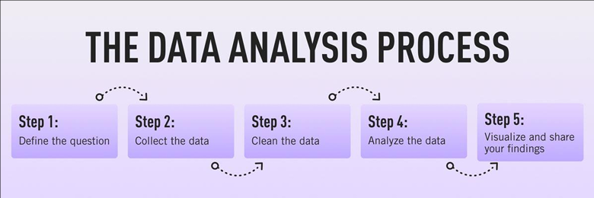

**Step 1: Define the Problem and Goals**

- Identify key issues affecting customer satisfaction, such as slow response times or product quality concerns.

- Communicate with stakeholders to understand their expectations and define a clear question or hypothesis.

- Example questions: "What factors lead to customer dissatisfaction?" or "How can we improve customer experience?"

**Step 2: Collect the Data**

- Gather customer feedback from various sources, such as surveys, reviews, and customer support interactions.

- Use internal sources like CRM systems, website analytics, and social media data.

- Categorize data into first-party (collected directly from customers), second-party (shared by partners), and third-party (purchased from external sources).

- Store data in spreadsheets or databases like SQL for further analysis.

**Step 3: Clean the Data**

- Remove duplicate, incorrect, or incomplete data to ensure accuracy.

- Standardize formats to make analysis easier.

- Ensure data is unbiased and represents all customer segments.

- Use tools like Excel, SQL functions, or Python libraries (Pandas) to clean the data.

**Step 4: Analyze the Data**

- Identify trends and patterns in customer behavior.

- Use statistical techniques like regression analysis, clustering, and sentiment analysis.

- Utilize tools like Excel (pivot tables), SQL (queries), and programming languages like Python and R for deeper analysis.

- Categorize insights into descriptive (past trends), diagnostic (reasons for trends), predictive (future outcomes), and prescriptive (recommendations for action).

**Step 5: Interpret and Present the Results**

- Transform data into clear and meaningful insights.

- Use charts, graphs, and dashboards to make data easily understandable for stakeholders.

- Visualization tools like Tableau, Looker, and Python's ggplot library can create compelling visuals.

- Share insights with teams to make data-driven decisions and improve customer satisfaction.

By following this workflow, companies can gain valuable insights into customer satisfaction, identify areas for improvement, and implement effective strategies.

**Q3) Illustrate Python Libraries for Data Visualization with suitable examples  
 a) Matplotlib  
 b) Seaborn**

**A)**

Data visualization is an essential part of data analysis. It helps in understanding patterns, trends, and insights in an easy and effective way. Two widely used Python libraries for data visualization are **Matplotlib** and **Seaborn**.

**a) Matplotlib**

Matplotlib is a low-level yet powerful library for creating various types of plots. It is built on NumPy and allows users to generate detailed visualizations with full control over customization.

**Installing Matplotlib**

To install Matplotlib, run the following command:

pip install matplotlib

**Common Plots in Matplotlib**

**1. Scatter Plot**- Used to show relationships between two variables.

**Code:**

import pandas as pd

import matplotlib.pyplot as plt

data = pd.read_csv("tips.csv")

plt.scatter(data['day'], data['tip'])

plt.title("Scatter Plot")

plt.xlabel("Day")

plt.ylabel("Tip")

plt.show()

**Output:**

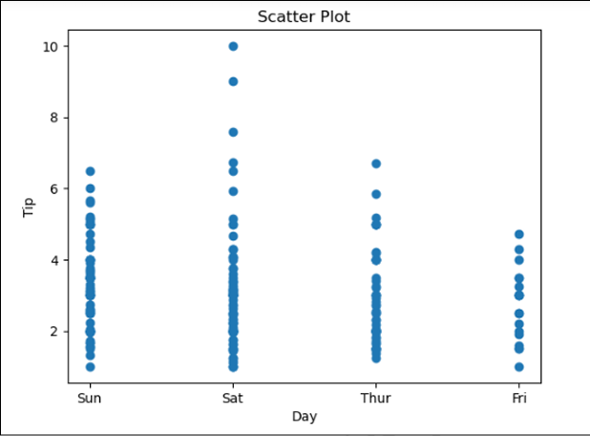

**2. Line Chart** - Shows trends over time by connecting data points.

**Code:**

import pandas as pd

import matplotlib.pyplot as plt

data = pd.read_csv("tips.csv")

plt.plot(data['tip'], label='Tip')

plt.plot(data['size'], label='Size')

plt.title("Line Chart")

plt.xlabel("Day")

plt.ylabel("Value")

plt.legend()

plt.show()

**Output:**

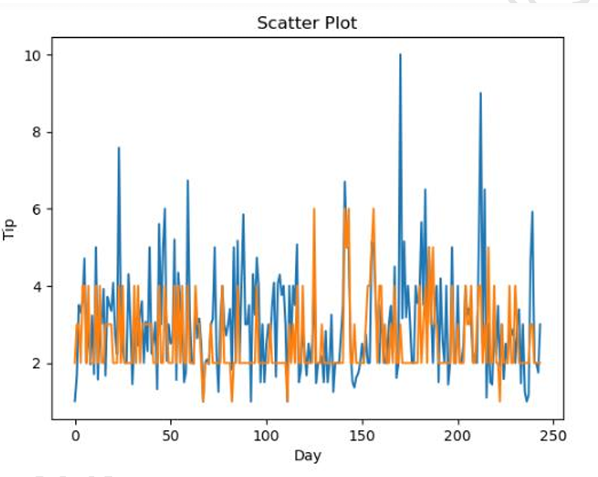

**3. Bar Chart** - Displays data using rectangular bars to compare different categories.

**Code:**

import pandas as pd

import matplotlib.pyplot as plt

data = pd.read_csv("tips.csv")

plt.bar(data['day'], data['tip'])

plt.title("Bar Chart")

plt.xlabel("Day")

plt.ylabel("Tip")

plt.show()

**Output:**

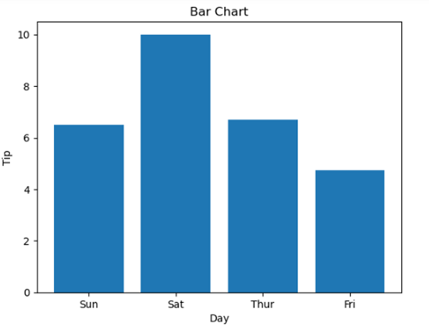

**4. Histogram** - Shows the distribution of numerical data.

**Code:**

import pandas as pd

import matplotlib.pyplot as plt

data = pd.read_csv("tips.csv")

plt.hist(data['total_bill'])

plt.title("Histogram")

plt.show()

**Output:**

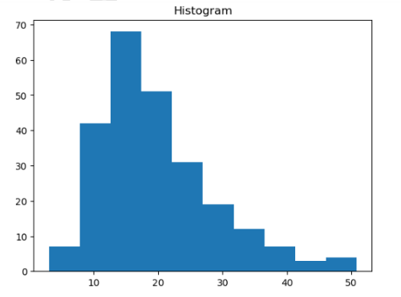

**b) Seaborn**

Seaborn is a high-level data visualization library built on Matplotlib. It provides more attractive and easy-to-use visualizations with better styling and color palettes.

**Installing Seaborn**

To install Seaborn, run the following command:

pip install seaborn

**Common Plots in Seaborn**

**1. Scatter Plot** - Similar to Matplotlib but with improved aesthetics.

**Code:**

import seaborn as sns

import matplotlib.pyplot as plt

import pandas as pd

data = pd.read_csv("tips.csv")

sns.scatterplot(x='day', y='tip', data=data)

plt.show()

**Output:**

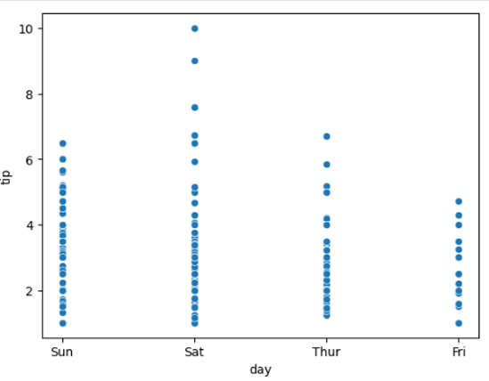

**2. Line Chart** - Used to visualize trends in data.

**Code:**

import seaborn as sns

import matplotlib.pyplot as plt

import pandas as pd

data = pd.read_csv("tips.csv")

sns.lineplot(x='day', y='tip', data=data)

plt.show()

**Output:**

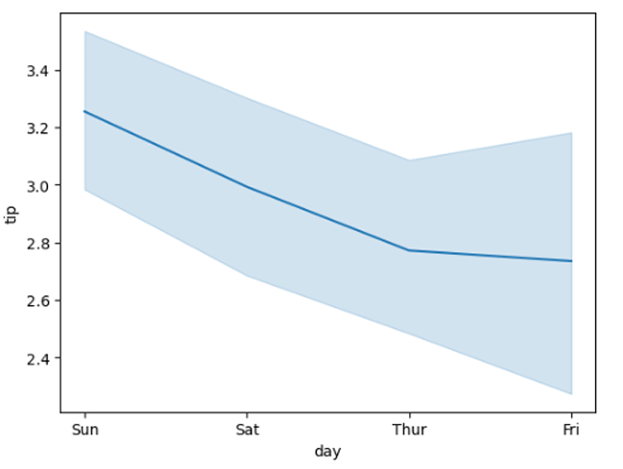

**3. Bar Chart** - A more visually enhanced bar chart.

**Code:**

import seaborn as sns

import matplotlib.pyplot as plt

import pandas as pd

data = pd.read_csv("tips.csv")

sns.barplot(x='day', y='tip', data=data, hue='sex')

plt.show()

**Output:**

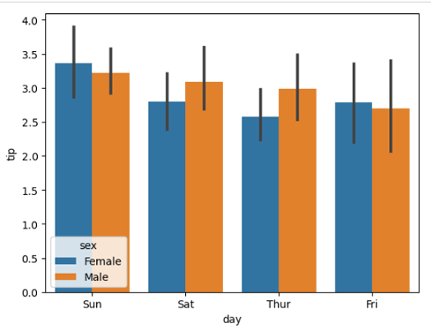

**4. Histogram** - Displays data distribution with an optional Kernel Density Estimate (KDE) curve.

**Code:**

import seaborn as sns

import matplotlib.pyplot as plt

import pandas as pd

data = pd.read_csv("tips.csv")

sns.histplot(x='total_bill', data=data, kde=True, hue='sex')

plt.show()

**Output:**

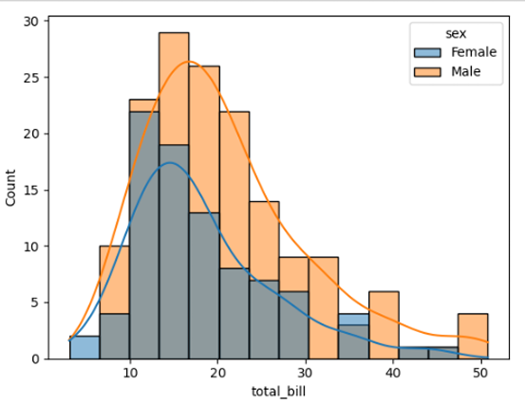

**Q4) Implement Python’s built-in data structures with examples program.**

**A)  
Built-in Data Structures in Python**

Python provides several built-in data structures, each with its unique properties and use cases. Here are four commonly used data structures:

1. **List**: An ordered and mutable collection that allows duplicate elements. Lists support indexing, slicing, and various built-in methods like append() and remove().
2. **Tuple**: An ordered and immutable collection, often used to group related data. It supports indexing and iteration.
3. **Set**: An unordered collection of unique elements. Sets support operations like union, intersection, and difference, but they do not allow indexing.
4. **Dictionary**: A collection of key-value pairs where keys are unique. Values can be accessed, added, or updated efficiently using the keys.

**Example of List in Python**

# Creating a List

numbers = [10, 20, 30, 40, 50]

# Accessing elements using indexing

print("First element:", numbers[0])

print("Last element:", numbers[-1])

# Slicing the List

print("Elements from index 1 to 3:", numbers[1:4])

# Adding multiple elements using extend()

numbers.extend([60, 70])

print("After extending the list:", numbers)

# Inserting an element at a specific index

numbers.insert(2, 25) # Insert 25 at index 2

print("After inserting 25 at index 2:", numbers)

# Removing an element using pop()

removed_element = numbers.pop()

print("Removed element:", removed_element)

print("After popping the last element:", numbers)

# Checking if an element exists in the list

if 25 in numbers:

print("25 is in the list")

# Clearing all elements in the List

numbers.clear()

print("List after clearing all elements:", numbers)

**Output:**

First element: 10

Last element: 50

Elements from index 1 to 3: [20, 30, 40]

After extending the list: [10, 20, 30, 40, 50, 60, 70]

After inserting 25 at index 2: [10, 20, 25, 30, 40, 50, 60, 70]

Removed element: 70

After popping the last element: [10, 20, 25, 30, 40, 50, 60]

25 is in the list

List after clearing all elements: []

**Example of Tuple in Python**

# Creating a Tuple

person = ("John", 25, "New York")

# Accessing elements using indexing

print("Name:", person[0])

print("Age:", person[1])

print("City:", person[2])

# Slicing the Tuple

print("First two elements:", person[:2])

# Iterating over the Tuple

print("Iterating over the Tuple:")

for item in person:

print(item)

# Checking if an element exists in the Tuple

if "John" in person:

print("John is in the tuple")

# Concatenating Tuples

address = ("USA", "East Coast")

full_info = person + address

print("Concatenated Tuple:", full_info)

# Repeating a Tuple

repeat_tuple = person * 2

print("Repeated Tuple:", repeat_tuple)

# Counting occurrences of an element

count_john = person.count("John")

print("Number of 'John' in the tuple:", count_john)

# Finding the index of an element

index_age = person.index(25)

print("Index of 25:", index_age)

**Output:**

Name: John

Age: 25

City: New York

First two elements: ('John', 25)

Iterating over the Tuple:

John

25

New York

John is in the tuple

Concatenated Tuple: ('John', 25, 'New York', 'USA', 'East Coast')

Repeated Tuple: ('John', 25, 'New York', 'John', 25, 'New York')

Number of 'John' in the tuple: 1

Index of 25: 1

**Example of Set in Python**

# Creating a Set

colors = {"red", "green", "blue", "yellow"}

print("Original colors set:", colors)

# Adding multiple elements using update()

colors.update({"purple", "orange"})

print("After updating with new colors:", colors)

# Removing an element using discard()

colors.discard("green")

print("After discarding 'green':", colors)

# Pop an arbitrary element from the set

popped_element = colors.pop()

print("Popped element:", popped_element)

print("After popping an element:", colors)

# Clearing the entire set

colors.clear()

print("After clearing the set:", colors)

**Output:**

Original colors set: {'yellow', 'green', 'blue', 'red'}

After updating with new colors: {'yellow', 'blue', 'orange', 'red', 'green', 'purple'}

After discarding 'green': {'yellow', 'blue', 'orange', 'red', 'purple'}

Popped element: yellow

After popping an element: {'blue', 'orange', 'red', 'purple'}

After clearing the set: set()

**Example of Dictionary in Python**

# Creating a Dictionary

student = {

"name": "John",

"age": 21,

"city": "New York"

}

# Accessing values using keys

print("Name:", student["name"])

print("Age:", student["age"])

print("City:", student["city"])

# Adding a new key-value pair

student["major"] = "Computer Science"

print("After adding major:", student)

# Updating a value for an existing key

student["age"] = 22

print("After updating age:", student)

# Removing a key-value pair using pop()

removed_value = student.pop("city")

print("Removed value:", removed_value)

print("After popping 'city':", student)

# Checking if a key exists in the dictionary

if "name" in student:

print("The key 'name' exists in the dictionary.")

# Getting all keys and values

print("Keys:", student.keys())

print("Values:", student.values())

**Output:**

Name: John

Age: 21

City: New York

After adding major: {'name': 'John', 'age': 21, 'city': 'New York', 'major': 'Computer Science'}

After updating age: {'name': 'John', 'age': 22, 'city': 'New York', 'major': 'Computer Science'}

Removed value: New York

After popping 'city': {'name': 'John', 'age': 22, 'major': 'Computer Science'}

The key 'name' exists in the dictionary.

Keys: dict_keys(['name', 'age', 'major'])

Values: dict_values(['John', 22, 'Computer Science'])

**Q5) Assume a dataset to calculate Central tendency. What are the limitations of each measure in representing the data?**

**A)**

Central tendency measures (mean, median, and mode) help summarize a dataset by identifying its center or typical value. However, each measure has limitations in representing the data accurately.

**Example Dataset:**

Consider the following dataset representing the ages of 10 people in a group:

Ages = [20, 22, 23, 24, 25, 26, 27, 28, 29, 100]

**1. Mean (Average)**

The mean is calculated by adding all values and dividing by the number of values.

For the dataset:

Mean = (20 + 22 + 23 + 24 + 25 + 26 + 27 + 28 + 29 + 100) / 10 = 30.4

**Limitations of the Mean**:

**- Sensitive to Outliers**: The mean is heavily influenced by extreme values. In this dataset, the age 100 is an outlier, which pulls the mean upward to 30.4, even though most ages are in the 20s. This makes the mean less representative of the majority of the data.

**- Not Always Reflective of the Data**: If the dataset is skewed (has extreme values), the mean may not accurately represent the "typical" value.

**2. Median (Middle Value)**

The median is the middle value when the data is sorted in ascending order. If there’s an even number of observations, it’s the average of the two middle values.

For the dataset:

Sorted Ages = [20, 22, 23, 24, 25, 26, 27, 28, 29, 100]

Median = (25 + 26) / 2 = 25.5

**Limitations of the Median:**

**- Ignores Extreme Values**: While the median is not affected by outliers (e.g., the age 100 doesn’t change the median), it also ignores the magnitude of those values. This can make it less informative in datasets where extreme values are important.

**- Less Sensitive to Changes**: The median only considers the middle value(s), so changes in other values (e.g., increasing the age 20 to 30) won’t affect the median unless the middle value changes.

---

**3. Mode (Most Frequent Value)**

The mode is the value that appears most frequently in the dataset.

For the dataset:

Ages = [20, 22, 23, 24, 25, 26, 27, 28, 29, 100]

Each age appears only once, so there is no mode.

If we modify the dataset to include repeated values:

Modified Ages = [20, 22, 23, 24, 25, 25, 26, 27, 28, 29]

Mode = 25 (appears twice).

**Limitations of the Mode:**

**- May Not Exist**: In datasets with no repeated values (like the original dataset), there is no mode.

**- Not Unique**: A dataset can have multiple modes (e.g., [20, 20, 22, 22, 23] has two modes: 20 and 22), which can make it confusing to interpret.

**- Ignores Other Values**: The mode only considers the most frequent value and ignores the rest of the data, which can make it less representative of the overall dataset.

**Note:**

- Use the mean when the data is symmetric and has no outliers.

- Use the median when the data is skewed or has outliers.

- Use the mode for categorical data or when identifying the most common value is important.

**Q6) Explain the Bayesian Rule and Bayes' Theorem applications in various fields.**

**A)**

Bayes' Theorem is a fundamental concept in probability and statistics. It helps us update our beliefs or predictions about an event based on new evidence or information. Think of it as a way to refine your guesses when you learn something new.

The formula for Bayes' Theorem is:

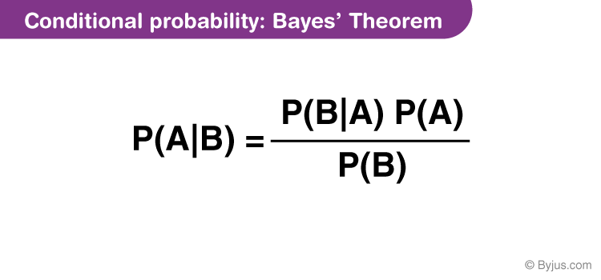

Where:

**- P(A|B)**: The probability of event A happening **given that** event B has occurred (this is called the **posterior probability**).

**- P(B|A)**: The probability of event B happening **given that** event A has occurred (this is called the **likelihood**).

**- P(A)**: The initial probability of event A happening (this is called the **prior probability**).

**- P(B)**: The total probability of event B happening.

**Example**

Bayes' theorem hinges on the principles of conditional probability. To illustrate, consider a simple card game where winning requires picking a queen from a full deck of 52 cards. The probability of picking a queen from the deck is calculated by dividing the number of queens (4) by the total number of cards (52). Thus, the probability of winning by picking a queen is approximately 7.69%.

Now, imagine picking a card and placing it face down. The dealer then says that the chosen card is a face card. This new condition influences the probability of winning. To calculate this conditional probability, use the equation P(A|B) = P(A ∩ B) / P(B), where P represents probability, | represents "given that,"A represents the event of interest and B represents the known condition.

Here, the probability of A (picking a queen) given B (the card is a face card) equals the probability of the card being both a queen and a face card (4/52) divided by the probability of the card being a face card (12/52). This simplifies to approximately 33.33%, as there are 4 queens among the 12 face cards.

Bayes' theorem extends this concept to situations where direct probabilities are unknown. It helps calculate conditional probability in complex scenarios by using inverse probabilities, which are often easier to determine. The theorem is expressed as follows:



Bayes' theorem states that the probability of A given B is equal to the probability of A multiplied by the probability of B given A, divided by the probability of B.

Here's how it applies to the card game example:

* **A** is the event of drawing a queen card.
* **B** is the event of drawing a face card.
* **P(A)** is the probability of drawing a queen (7.69%).
* **P(B)** is the probability of drawing a face card (23.08%).
* **P(A|B)** is the probability of drawing a queen given that the chosen card is a face card.
* **P(B|A)** is the probability of drawing a face card given that the chosen card is a queen (100%).

Inputting these numbers into Bayes' theorem results in the following:

P(A|B) = (7.69% * 100%) / 23.08% = 33.33%

**Applications of Bayes' Theorem in Various Fields**

Bayes' Theorem is widely used in many fields because it provides a way to incorporate new information into existing knowledge. Here are some key applications:

**1. Medicine and Healthcare**

**- Disease Diagnosis**: As in the example above, Bayes' Theorem helps calculate the probability of having a disease based on test results and prior knowledge (e.g., prevalence of the disease).

**- Drug Development**: It’s used to evaluate the effectiveness of new treatments by combining prior clinical trial data with new experimental results.

**2. Machine Learning and Artificial Intelligence**

**- Spam Filtering**: Email services like Gmail use Bayes' Theorem to classify emails as spam or not spam based on the probability of certain words appearing in spam emails.

**- Recommendation Systems**: Platforms like Netflix or Amazon use Bayesian methods to predict what movies or products you might like based on your past behavior.

**3. Finance and Economics**

**- Risk Assessment**: Banks and insurance companies use Bayes' Theorem to update the probability of default or risk based on new customer data.

**- Stock Market Prediction**: Investors use Bayesian models to update their predictions about stock prices based on new market trends or news.

**4. Engineering and Robotics**

**- Sensor Data Analysis**: Robots use Bayes' Theorem to interpret sensor data and make decisions. For example, a self-driving car updates its understanding of the environment based on new sensor inputs.

**- Quality Control**: Engineers use Bayesian methods to predict the likelihood of defects in manufacturing processes.

**Q7) Describe and interpret the following terms:**

**a) Conditional Probability**

**b) Relative frequency method**

**A)**

**(a) Conditional Probability:**

Conditional probability is a principle in probability theory. It relates to the probability that a certain event will occur based on the fact that a previous event has already occurred.

It involves two or more events that are not independent, and asks, "If we know A has happened, what's the chance of B also happening?" Conditional probability is calculated by multiplying the probability of the preceding event by the updated probability of the succeeding, or conditional, event.

**Key Takeaways**

* Conditional probability refers to the chances that some outcome (A) occurs given that another event (B) has already occurred.
* In probability, this is written as A given B, or as this formula: P(A|B), where the probability of A happening depends on that of B happening.
* Conditional probability can be contrasted with unconditional probability.
* Probabilities are classified as conditional, marginal (the base probability without any dependence on another event), or joint (the probability of two events occurring together).
* Bayes' theorem is a mathematical formula that can calculate conditional probabilities dealing with uncertain events.

**Understanding Conditional Probability**

Conditional probability measures the likelihood of a certain outcome (A), based on the occurrence of some earlier event (B).

Two events are said to be independent if one event occurring does not affect the probability that the other event will occur. However, if one event occurring (or not occurring) does affect the likelihood that the other event will happen, the two events are said to be dependent.

An example of dependent events is a company's stock price increasing after the company reports higher-than-expected earnings.

If events are independent, then the probability of event B occurring is not contingent on what happens with event A. For example, an increase in Apple's shares has nothing to do with a drop in wheat prices.

Conditional probability is often written as the "probability of A *given* B" and notated as P(A|B).

**Conditional Probability Formula**

P(B∣A)=P(A and B)/P(A)

Or:

P(B∣A)=P(A∩B)/P(A)

Where the letters are for the following:

P = Probability

A = Event A

B = Event B

**Example : Marbles in a Bag**

An example of conditional probability using marbles is illustrated below. The steps are as follows:

**Step 1**: **Understand the scenario**

Initially, you're given a bag with six red marbles, three blue marbles, and one green marble. Thus, there are 10 marbles in the bag.

**Step 2**: **Identify the events**

Two events are defined:

* Event A: Drawing a red marble from the bag
* Event B: Drawing a marble that is not green

**Step 3**: **Calculate the probability of event B: P(B)**

Event B is drawing a marble that is not green. There are 10 marbles altogether, nine of which are not green: the six red and three blue marbles.

P(B)=(Number of marbles that are not green)/(Total number of marbles)=9/10

**Step 4**: **Identify the intersection of events A and B: P(A∩B)**

The intersection of events A and B involves drawing a red marble that is also not green. Since all red marbles are not green, the intersection is simple: the event of drawing a red marble.

**Step 5**: **Calculate the probability of the intersection of events A and B: P(A∩B)**

P(A∩B)=(Number of red marbles)/(Total number of marbles)=6/10=3/5

**Step 6**: **Calculate the conditional probability: P(A|B)**

Using the conditional probability formula, P(A|B), that is, the probability of drawing a red marble given that the marble drawn is not green, the probability is calculated.

P(A∣B)=P(A∩B)/P(B)=(3/5)/(9/10)=2/3

**Result:** The conditional probability of drawing a red marble given that the marble drawn is not green, is 2/3.

**What is Meant by Relative Frequency?**

**Relative frequency can be defined as the number of times an event occurs divided by the total number of events occurring in a given scenario.**

To calculate the relative frequency two things must be known:

* Number of total events/trials
* Frequency count for a category/subgroup

|  |
| --- |
| Relative Frequency**=**Subgroup frequency/Total frequency |

**Example:**

Ellie surveys a group of students in her school to learn about their favorite sport. The data collected has been presented below. What will be the relative frequency for volleyball?

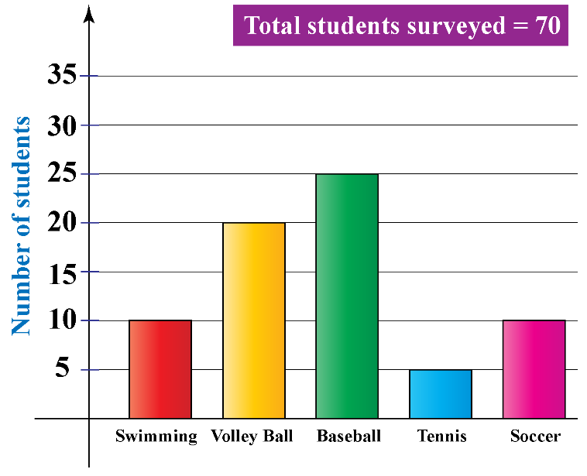

The total number of students in the data set is found by adding the heights of all the bars  
=10+20+25+5+10=70=10+20+25+5+10=70

The number of students who like volleyball =20=20

So, the relative frequency for the Volleyball will be 2070=28.572070=28.57 (to two decimals)

The above frequency can also be expressed simply as a fraction 2727

**Q8) Describe and explain the Chi-Square Test and demonstrate how it works.**

**A)**

The Chi-Square Test is a statistical method used to determine if there is a significant difference between observed and expected data in categorical variables. It helps us understand whether any differences in data are due to chance or if they reflect a real relationship or pattern.

**Types of Chi-Square Tests:**

**1. Chi-Square Goodness of Fit Test**: This test checks if a sample matches the expected distribution of a population. For example, if you want to see if the colors of candies in a bag match the expected distribution.

**2. Chi-Square Test of Independence**: This test checks if two categorical variables are independent of each other. For example, it can be used to determine if there is a relationship between gender and preference for a type of movie.

**How the Chi-Square Test Works:**

**1. Set Up Hypotheses**:

- Null Hypothesis (H₀): Assumes there is no significant difference between observed and expected data (or no relationship between variables).

- Alternative Hypothesis (H₁): Assumes there is a significant difference or relationship.

**2. Collect Data:**

Gather observed data and calculate the expected data based on the null hypothesis.

**3. Calculate the Chi-Square Statistic:**

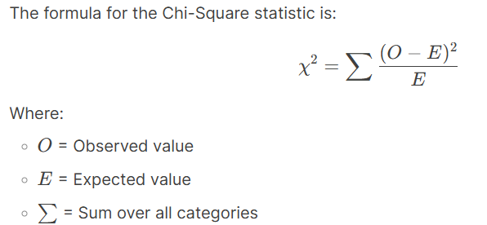

**4. Determine Degrees of Freedom (df)**:

Degrees of freedom depend on the number of categories or variables:

- For Goodness of Fit: df = Number of categories - 1

- For Test of Independence: df = (Number of rows - 1) X (Number of columns – 1)

**5. Compare to Critical Value:**

Use a Chi-Square distribution table to find the critical value based on the degrees of freedom and a chosen significance level (e.g., 0.05). If the calculated Chi-Square statistic is greater than the critical value, reject the null hypothesis.

**6. Interpret Results:**

- If the null hypothesis is rejected, it means there is a significant difference or relationship.

- If it is not rejected, the observed data is consistent with the expected data.

**Example: Chi-Square Test of Independence**

Suppose you want to test if there is a relationship between gender (Male, Female) and preference for a type of movie (Action, Comedy).

Observed Data:

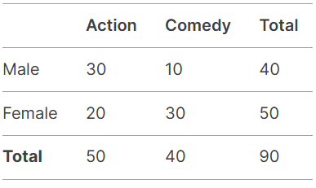

**Step 1: Hypotheses**

- H₀: Gender and movie preference are independent.

- H₁: Gender and movie preference are related.

**Step 2: Calculate Expected Values**

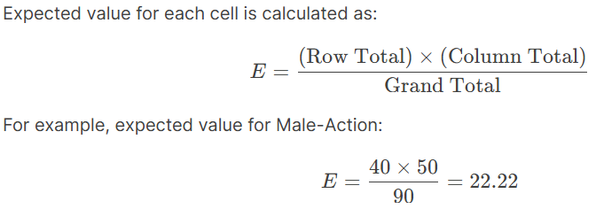

**Step 3: Calculate Chi-Square Statistic**

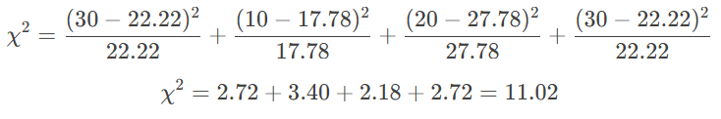

**Step 4: Degrees of Freedom**

df = (2-1) X (2-1) = 1

**Step 5: Compare to Critical Value**

For df = 1 and a significance level of 0.05, the critical value is 3.84. Since 11.02 > 3.84, we reject the null hypothesis.

**Step 6: Conclusion**

There is a significant relationship between gender and movie preference.

**Code:**import numpy as np

from scipy.stats import chi2_contingency

# Observed data

observed_data = np.array([

[30, 10], # Male: Action, Comedy

[20, 30] # Female: Action, Comedy

])

# Perform Chi-Square Test

chi2_stat, p_value, dof, expected = chi2_contingency(observed_data)

# Output results

print("Observed Data:")

print(observed_data)

print("\nExpected Data:")

print(expected)

print(f"\nChi-Square Statistic: {chi2_stat:.2f}")

print(f"P-value: {p_value:.4f}")

print(f"Degrees of Freedom: {dof}")

print("\nConclusion:")

if p_value < 0.05:

print("Reject the null hypothesis: There is a significant relationship between gender and movie preference.")

else:

print("Fail to reject the null hypothesis: There is no significant relationship between gender and movie preference.")

**Output:**

Observed Data:

[[30 10]

[20 30]]

Expected Data:

[[22.22222222 17.77777778]

[27.77777778 22.22222222]]

Chi-Square Statistic: 11.02

P-value: 0.0009

Degrees of Freedom: 1

Conclusion:

Reject the null hypothesis: There is a significant relationship between gender and movie preference.

**Q9) Describe and explain the types of Student t-Tests, and illustrate with an example**

**A)**

The Student t-Test is a statistical method used to compare the means of two groups and determine if they are significantly different from each other. It is widely used in research, experiments, and data analysis. There are three main types of t-tests, each used in different scenarios:

**Types of t-Tests:**

**1. One-Sample t-Test:**

- Compares the mean of a single group to a known value or theoretical mean.

- Example: Testing if the average height of a class of students is different from the national average height.

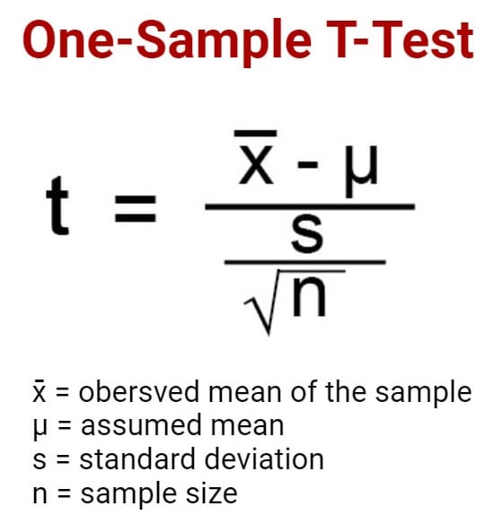

**2. Independent Two-Sample t-Test:**

- Compares the means of two independent (unrelated) groups.

- Example: Testing if the average test scores of students from two different schools are significantly different.

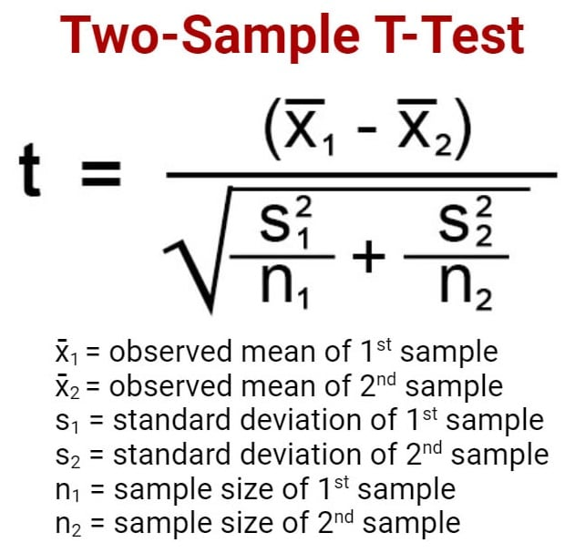

**3. Paired t-Test:**

- Compares the means of the same group at two different times or under two different conditions.

- Example: Testing if a group of patients has significantly different blood pressure levels before and after taking a medication.

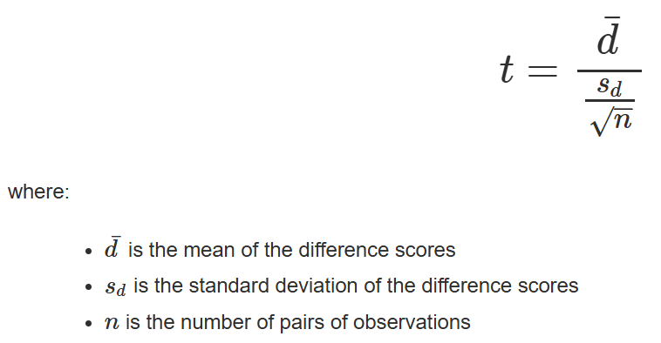

**How the t-Test Works:**

**1. Set Up Hypotheses:**

- Null Hypothesis (H₀): There is no significant difference between the means.

- Alternative Hypothesis (H₁): There is a significant difference between the means.

**2. Calculate the t-Statistic:**

The formula for the t-statistic depends on the type of t-test, but it generally measures the difference between the means relative to the variability in the data.

**3. Determine Degrees of Freedom (df):**

Degrees of freedom depend on the sample size and the type of t-test.

**4. Compare to Critical Value or p-value:**

- Use a t-distribution table or software to find the critical value or p-value.

- If the calculated t-statistic is greater than the critical value (or if the p-value is less than the significance level, e.g., 0.05), reject the null hypothesis.

**5. Interpret Results:**

- If the null hypothesis is rejected, it means there is a significant difference between the means.

- If it is not rejected, there is no significant difference.

**Example: Independent Two-Sample t-Test**

Suppose you want to compare the average test scores of students from two different schools (School A and School B) to see if there is a significant difference.

**Data:**

- School A: [85, 88, 90, 87, 86]

- School B: [82, 84, 83, 85, 81]

**Step 1: Hypotheses**

- H₀: There is no significant difference in the average test scores of School A and School B.

- H₁: There is a significant difference in the average test scores of School A and School B.

**Step 2: Calculate the t-Statistic**

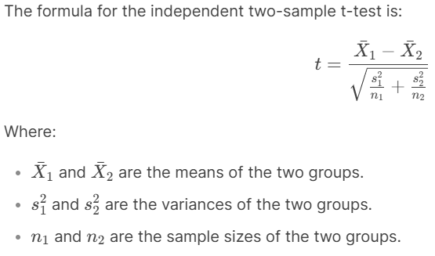

**Step 3: Degrees of Freedom**

For an independent two-sample t-test:

df = n1 + n2 - 2

**Step 4: Compare to Critical Value or p-value**

Using a t-distribution table or software, compare the calculated t-statistic to the critical value or check the p-value.

**Step 5: Interpret Results**

If the p-value is less than 0.05 (or the t-statistic is greater than the critical value), reject the null hypothesis.

**Code:**

import scipy.stats as stats

# Data for School A and School B

school_a = [85, 88, 90, 87, 86]

school_b = [82, 84, 83, 85, 81]

# Perform independent two-sample t-test

t_stat, p_value = stats.ttest_ind(school_a, school_b)

# Output results

print(f"t-Statistic: {t_stat:.2f}")

print(f"P-value: {p_value:.4f}")

# Conclusion

if p_value < 0.05:

print("Reject the null hypothesis: There is a significant difference in the average test scores.")

else:

print("Fail to reject the null hypothesis: There is no significant difference in the average test scores.")

**Output:**

t-Statistic: 3.24

P-value: 0.0119

Reject the null hypothesis: There is a significant difference in the average test scores.

**Q10) Why is sampling important in research? Discuss how the choice between Simple Random and Cluster Sampling can impact the results.**

**A)**

Sampling is a critical aspect of research because it allows researchers to study a subset of a population rather than the entire population. This is important because studying an entire population is often impractical due to time, cost, and logistical constraints. By selecting a representative sample, researchers can draw valid conclusions about the entire population.

**Why is Sampling Important?**

**1. Cost-Effective:**

- Studying an entire population can be expensive. Sampling reduces costs by focusing on a smaller, manageable group.

**2. Time-Saving:**

- Collecting data from an entire population can take a long time. Sampling speeds up the research process.

**3. Feasibility:**

- In some cases, it is impossible to study the entire population (e.g., if the population is too large or spread out).

**4. Accuracy:**

- A well-designed sample can provide accurate and reliable results that reflect the entire population.

**5. Practicality:**

- Sampling allows researchers to focus on specific groups or subgroups within a population, making the research more targeted and practical.

**Types of Sampling Methods:**

Two common sampling methods are Simple Random Sampling and Cluster Sampling. The choice between these methods can significantly impact the results of a study.

**1. Simple Random Sampling:**

- What it is: Every individual in the population has an equal chance of being selected for the sample.

- How it works: Researchers use random methods (e.g., random number generators) to select participants.

- Example: If you want to study the average height of students in a school, you could randomly select 50 students from the entire student population.

**Advantages:**

- Unbiased: Every individual has an equal chance of being selected, reducing bias.

- Simple to Understand: Easy to implement and explain.

**Disadvantages:**

- Requires a Complete List: You need a complete list of the population, which may not always be available.

- May Not Capture Subgroups: If the population has distinct subgroups, simple random sampling might not adequately represent them.

**2. Cluster Sampling:**

- What it is: The population is divided into groups (clusters), and entire clusters are randomly selected for the sample.

- How it works: Researchers randomly select clusters and include all individuals within those clusters in the sample.

- Example: If you want to study the average income of households in a city, you could divide the city into neighborhoods (clusters) and randomly select a few neighborhoods to study.

**Advantages:**

- Cost-Effective: Reduces costs and time, especially when the population is spread out.

- Practical for Large Populations: Useful when the population is large and geographically dispersed.

**Disadvantages:**

- Less Precise: Results may be less accurate because individuals within a cluster may be similar to each other.

- Risk of Bias: If the clusters are not representative of the population, the results may be biased.

**How the Choice of Sampling Method Impacts Results:**

**1. Representativeness:**

- Simple random sampling is more likely to produce a representative sample because every individual has an equal chance of being selected.

- Cluster sampling may not be as representative if the clusters themselves are not diverse.

**2. Precision:**

- Simple random sampling generally provides more precise results because it minimizes bias.

- Cluster sampling can introduce variability if the clusters are not homogeneous.

**3. Cost and Feasibility:**

- Simple random sampling can be expensive and time-consuming if the population is large or spread out.

- Cluster sampling is more cost-effective and practical for large or geographically dispersed populations.

**4. Subgroup Analysis:**

- Simple random sampling may not adequately capture small subgroups within the population.

- Cluster sampling can be designed to ensure that specific subgroups are included in the sample.

**Example Scenario:**

Suppose you want to study the academic performance of high school students in a country.

**- Simple Random Sampling:**

- You randomly select students from all high schools in the country.

- This method ensures that every student has an equal chance of being selected, but it may be costly and time-consuming to collect data from students spread across the country.

**- Cluster Sampling:**

- You divide the country into regions (clusters) and randomly select a few regions. Then, you include all students from the selected regions in your sample.

- This method is more cost-effective and practical, but the results may be less precise if the selected regions are not representative of the entire country.

**Q11) Define the following terms related to hypothesis testing:**

**a) Null hypothesis (H₀)**

**b) Alternative hypothesis (H₁)**

**A)**

Hypothesis testing is a statistical method used to make decisions or draw conclusions about a population based on sample data. It involves two competing hypotheses: the null hypothesis (H₀) and the alternative hypothesis (H₁). These hypotheses are central to determining whether observed data provides enough evidence to support a specific claim or theory.

**a) Null Hypothesis (H₀):**

**- Definition**: The null hypothesis is a statement that assumes there is no effect, no difference, or no relationshi between variables. It represents the default or status quo position.

**- Purpose**: It serves as a starting point for testing. Researchers aim to either reject or fail to reject the null hypothesis based on the evidence from the data.

**- Example**:

- If you are testing whether a new drug is effective, the null hypothesis might be: "The new drug has no effect on patients compared to a placebo."

- If you are comparing the average heights of men and women, the null hypothesis might be: "There is no difference in the average height of men and women."

**Key Characteristics:**

- It is always written as an equality (e.g., μ1 = μ2 or p = 0.5).

- It assumes that any observed difference in the data is due to random chance or sampling error.

- The goal of hypothesis testing is to determine whether there is enough evidence to reject the null hypothesis.

**b) Alternative Hypothesis (H₁):**

**- Definition**: The alternative hypothesis is a statement that contradicts the null hypothesis. It represents the research question or the effect, difference, or relationship that the researcher wants to test.

**- Purpose**: It provides an alternative explanation to the null hypothesis and is accepted if the null hypothesis is rejected.

**- Example**:

- For the drug effectiveness test, the alternative hypothesis might be: "The new drug has a significant effect on patients compared to a placebo."

- For the height comparison, the alternative hypothesis might be: "There is a significant difference in the average height of men and women."

**Key Characteristics:**

- It is written as an inequality (e.g., μ1≠ μ2, μ1 > μ2, or μ1 < μ2).

- It reflects the researcher's belief or the effect they are trying to detect.

- It is only accepted if the data provides strong enough evidence to reject the null hypothesis.

**Relationship Between H₀ and H₁:**

- The null and alternative hypotheses are **mutually exclusive** and **exhaustive**. This means:

- If H₀ is true, H₁ must be false.

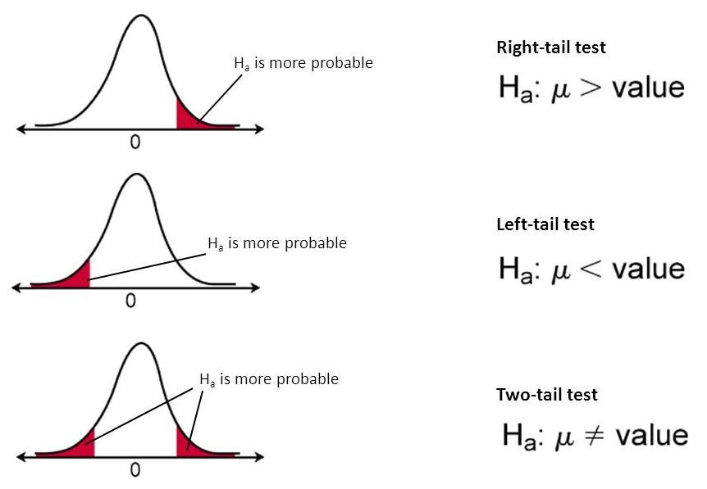

**Q12) What is a Type I Error, and what are the impacts of a False Positive in statistical hypothesis testing?**

**A)**

**Type I and Type II Errors in Hypothesis Testing**

Type I and Type II errors are directly related to the outcome of a null hypothesis (H0). In hypothesis testing:

* A **Type I Error** occurs when the null hypothesis is rejected even though it is actually true.
* A **Type II Error** occurs when the null hypothesis is not rejected, even when the alternative hypothesis (H1) is true.

These errors are also known as false positives (Type I) and false negatives (Type II). Many statistical methods aim to reduce these errors, but completely eliminating both is considered statistically impossible.

**Type I Error (False Positive)**

A Type I Erro**r** happens when the null hypothesis (H0) is true, but we mistakenly reject it. This means we detect an effect or relationship when none actually exists.

- **Example**: Imagine someone falsely believes they see a bear in the forest and raises an alarm, even though no bear is present. Here, the null hypothesis states, *"There is no bear,"* but it is incorrectly rejected.

The probability of making a Type I Error is called the **significance level (α)**, commonly set at **0.05 (5%)**. This means there is a 5% chance of wrongly rejecting a true null hypothesis.

**Type II Error (False Negative)**

A **Type II Error** happens when the null hypothesis (H0H_0) is false, but we fail to reject it. This means we overlook an effect or relationship that actually exists.

- **Example**: Imagine a person fails to notice a real bear in the forest and does not raise an alarm. Here, the null hypothesis states, *"There is no bear,"* and it is wrongly accepted despite a bear being present.

The probability of making a Type II Error is represented by **β (beta)** and is linked to the **power of a test**, which is **1 − β\beta**. A higher statistical power reduces the likelihood of a Type II Error, improving the test’s ability to detect true effects.

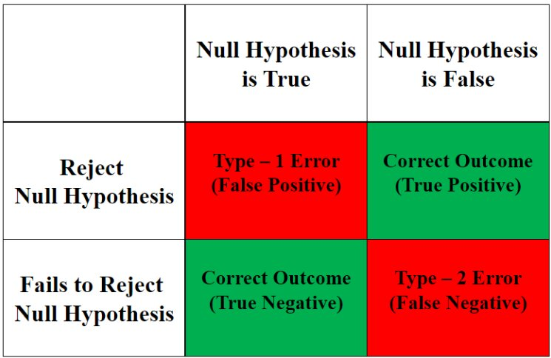

**Impacts of a False Positive (Type I Error) in Hypothesis Testing**

A **False Positive** can have serious consequences depending on the situation. Here are some real-world examples:

1. **Medical Testing**:
   * If a test falsely detects a disease (when the person is healthy), the person may undergo unnecessary treatments, which can be costly, painful, or harmful.
2. **Judicial System** (Court Trials):
   * Suppose a court assumes someone is guilty when they are actually innocent. This leads to wrongful convictions, causing harm to innocent people.
3. **Quality Control in Manufacturing**:
   * A factory might reject a perfectly good product because a test falsely shows it is defective. This leads to wasted resources and increased costs.
4. **Business and Marketing**:
   * A company might believe a new marketing strategy works (when it actually doesn’t) and invest heavily in it, leading to financial losses.

**How to Reduce Type I Errors?**

* Lower the **significance level (α)**, which is the probability of making a Type I Error. Common choices are **0.05 (5%)** or **0.01 (1%)**, meaning we only accept a small chance of a False Positive.
* Use better experimental designs and larger sample sizes to improve accuracy.
* Apply corrections (like the Bonferroni correction) when performing multiple tests to avoid false positives.